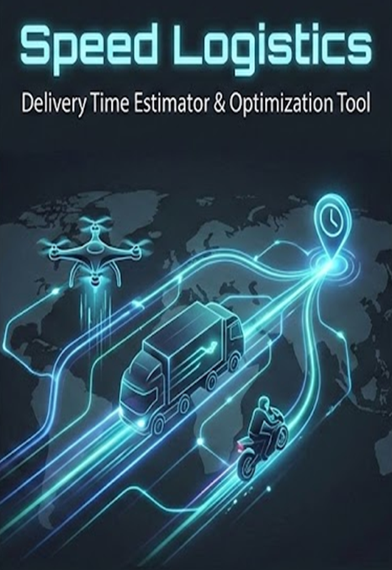

Student Name-Tanish Sikarwar
Registration no.-25BCE10829
Subject-CSE
VIT Bhopal university

Introduction

In the modern logistics industry, efficiency is paramount. Small businesses and independent dispatchers often struggle with estimating accurate delivery times, leading to customer dissatisfaction.
"Speed Logistics" is a Python-based desktop application designed to solve this problem. By automating the calculation of delivery estimates based on distance and vehicle type, this tool provides a fast, consistent, and error-free way to schedule deliveries. Unlike basic calculators, this system accounts for real-world variables such as vehicle speed limits and mandatory handling/buffer times.

Problem Statement

Manual calculation of delivery times is prone to human error and inconsistency. Dispatchers often guess travel times without mathematically accounting for:
- Different speeds for different vehicles (e.g., a Drone is faster than a Bike).
- Non-travel time (packing, parking, traffic).
- Input validation errors.
Goal: To develop a GUI-based application that accepts distance and vehicle type as input and outputs a precise delivery time breakdown.

Functional Requirements
The system must perform the following functions:
- Input Handling: Accept numerical input for "Distance" (in km) and allow selection of "Vehicle Type" via a dropdown menu.
- Processing Logic: Apply the physics formula (s=d/t) based on the selected vehicle's pre-defined speed.
- Buffer Addition: Automatically add a fixed 15-minute buffer for handling and traffic.
- Output Display: Show a detailed text breakdown of Travel Time vs. Total Time.
- Error Handling: Detect non-numeric inputs and display an error popup instead of crashing.

Non-functional Requirements
- Usability: The interface must use a high-contrast "Dark Mode" theme for better readability and reduced eye strain.
- Performance: Calculations must be instantaneous (< 1 second).
- Reliability: The application must be robust enough to handle invalid user actions without closing unexpectedly.
- Portability: The application must run on any system with Python installed.

System Architecture
The system follows a simple Event-Driven Architecture suitable for desktop GUI applications.
- Presentation Layer (GUI): Built using Tkinter. Handles user inputs and displays results.
- Logic Layer (Controller): Python functions that handle variable mapping, mathematical calculations, and exception handling.
- Data Layer: Temporary in-memory storage (variables) for the duration of the session.

Implementation Details
Core Logic Snippet: The backbone of the project is the speed mapping logic:
# Logic to determine speed based on vehicle selection
if vehicle type == "Bike":
speed = 40
elif vehicle type == "Car":
speed = 60
elif vehicle type == "Drone":
speed = 100
else:
speed = 40

# Physics Calculation
Travel mins = (distance / speed) * 60
Total mins = travel mins + 15 # Buffer
Tools Used:
- IDE: Visual Studio Code
- Interpreter: Python 3.12
- Libraries: tkinter (GUI), messagebox (Popups)

Screenshots / Results
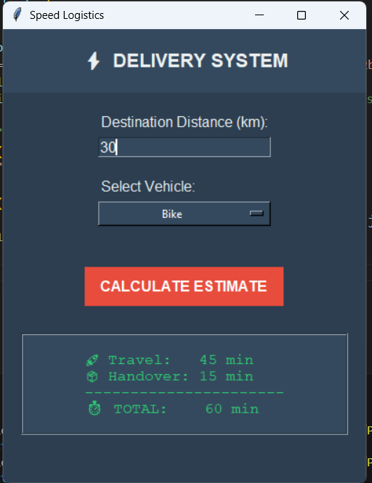

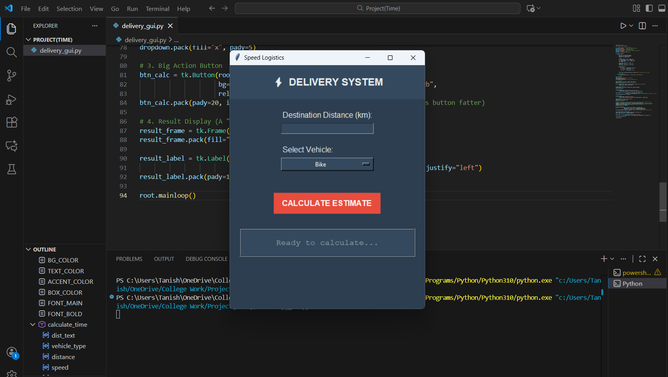

Flowchart
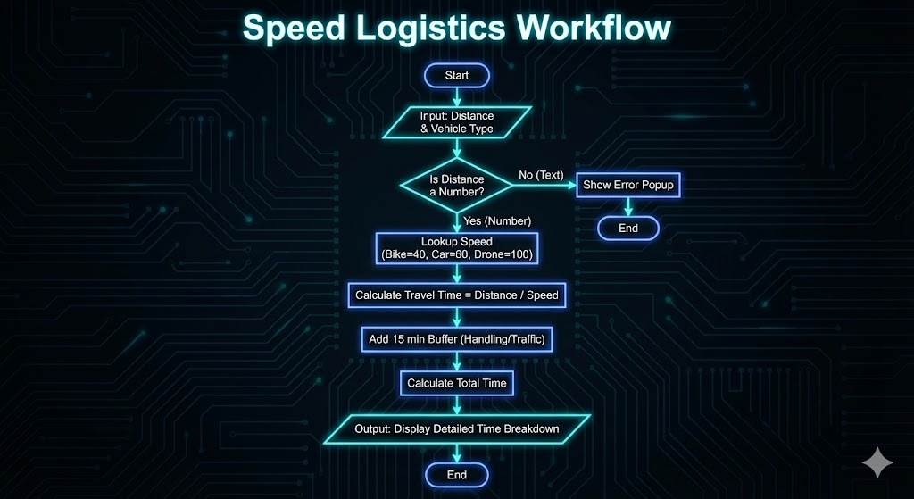

Challenges Faced
- Layout Management: Understanding the difference between pack() and grid() in Tkinter was initially confusing. I resolved this by using pack() with Frames to organize the window cleanly.
- Data Types: Input from text boxes comes as a String. I had to learn to convert this to Float using float() and wrap it in a try-except block to prevent crashes.

Thank you

